Ideation Phase

Brainstorm & Idea Prioritization Template — LearnHub Online Learning Platform

Date | 9 February 2026
Team ID | LTVIP2026TMIDS78241
Project Name | LearnHub — Online Learning Platform (OLP)
Maximum Marks | 4 Marks

Brainstorm & Idea Prioritization Template:
Brainstorming provides a free and open environment that encourages everyone within the LearnHub team to participate in the creative thinking process for solving challenges related to the Online Learning Platform (OLP). For LearnHub, this involves generating ideas around features such as course management, user experience, certification systems, payment models, and instructor tools. Prioritizing volume over value, out-of-the-box ideas are welcome and built upon, and all participants are encouraged to collaborate on building a richer, more accessible learning experience.
Use this template in your LearnHub OLP brainstorming sessions so your team can generate ideas for features like self-paced learning, interactive forums, instructor dashboards, and certification workflows — even when collaborating remotely.
Reference: https://www.mural.co/templates/brainstorm-and-idea-prioritization

Step-1: Team Gathering, Collaboration and Select the Problem Statement (LearnHub OLP)
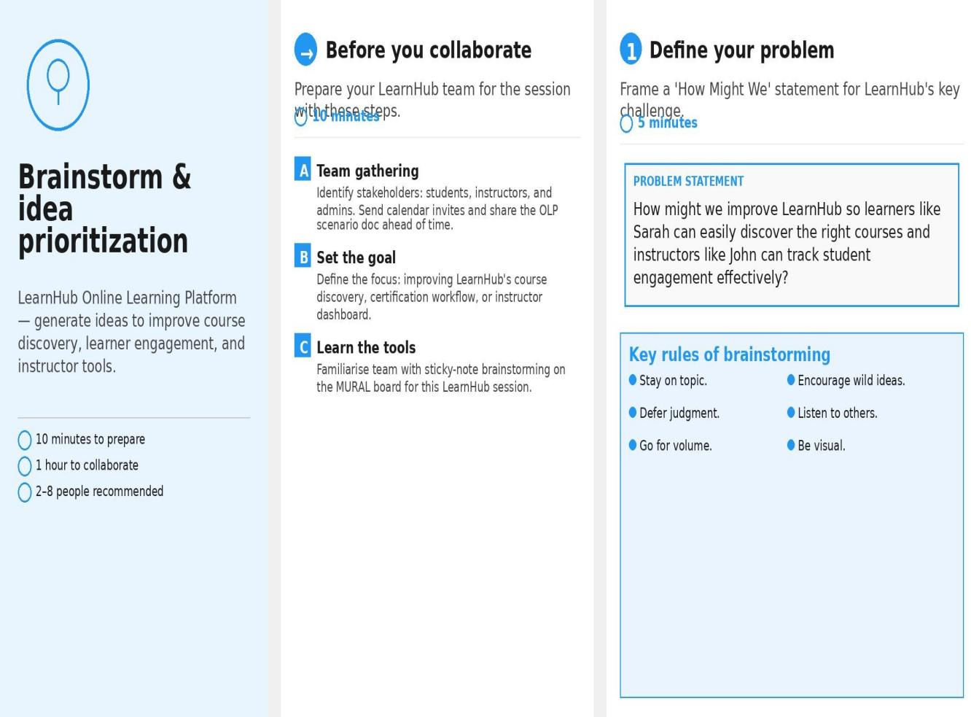

Step-2: Brainstorm, Idea Listing and Grouping

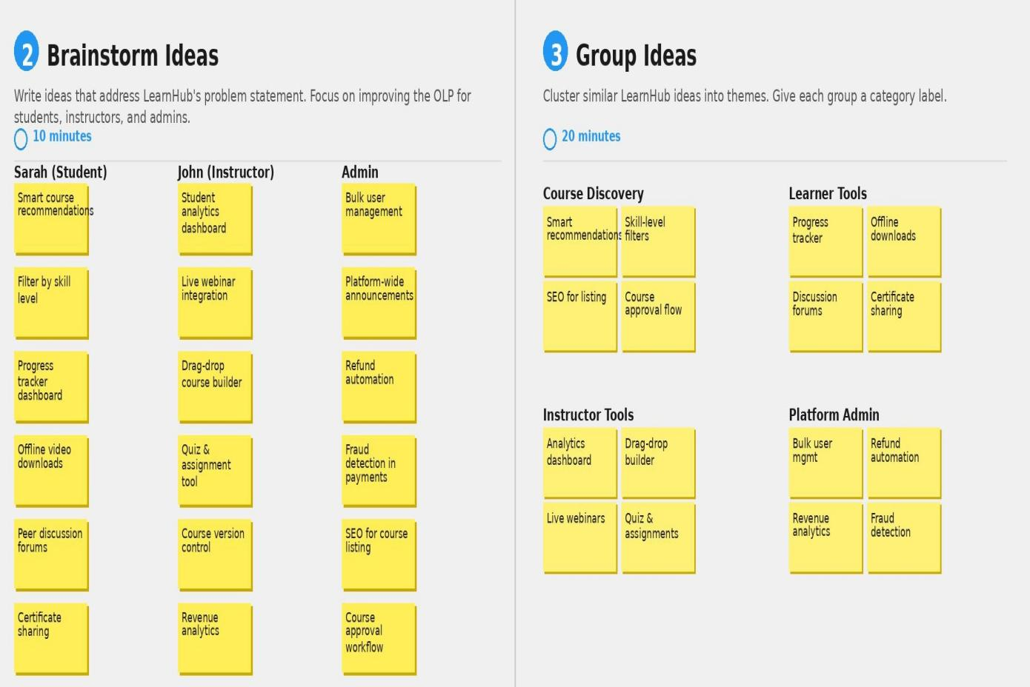

Step-3: Idea Prioritization
